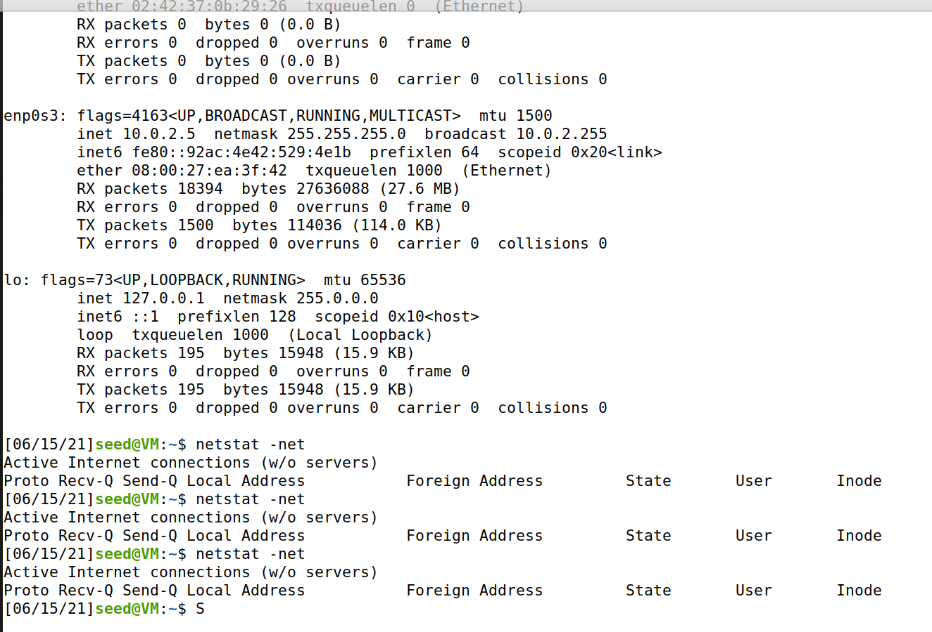

After running synflood.c

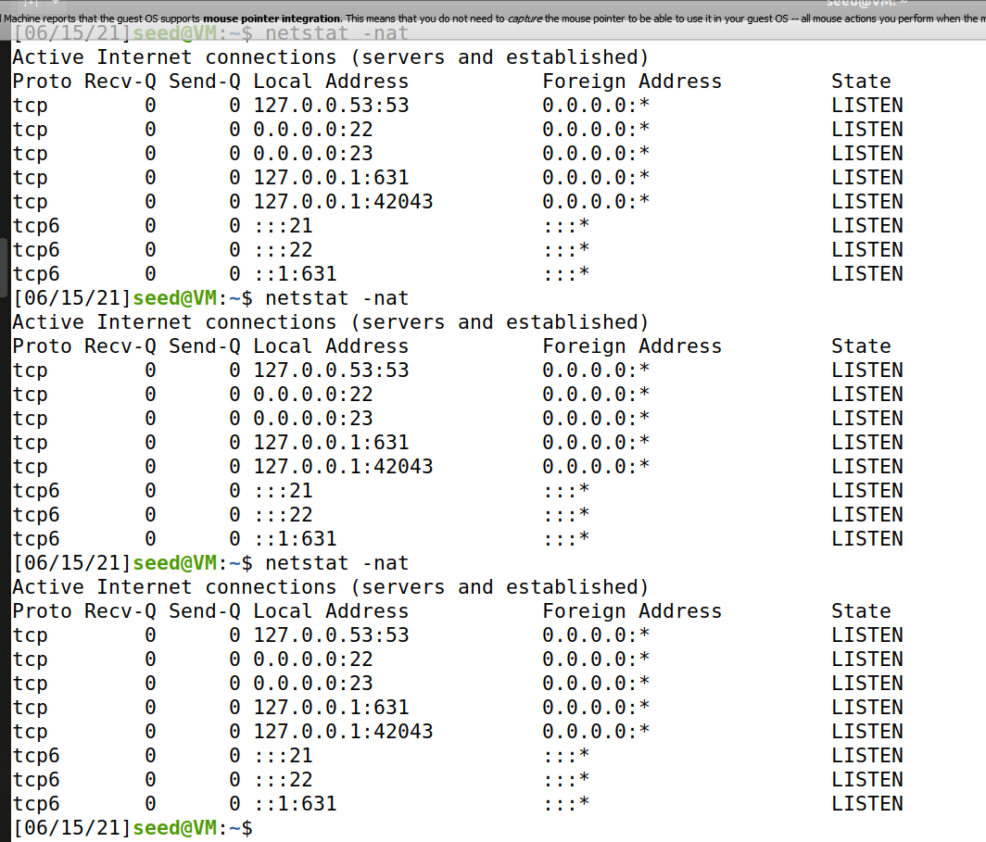

This is the third machine using Telnet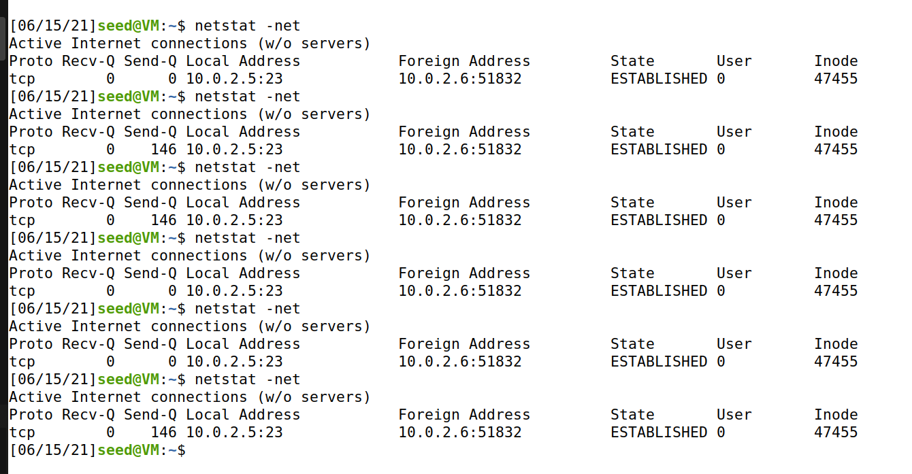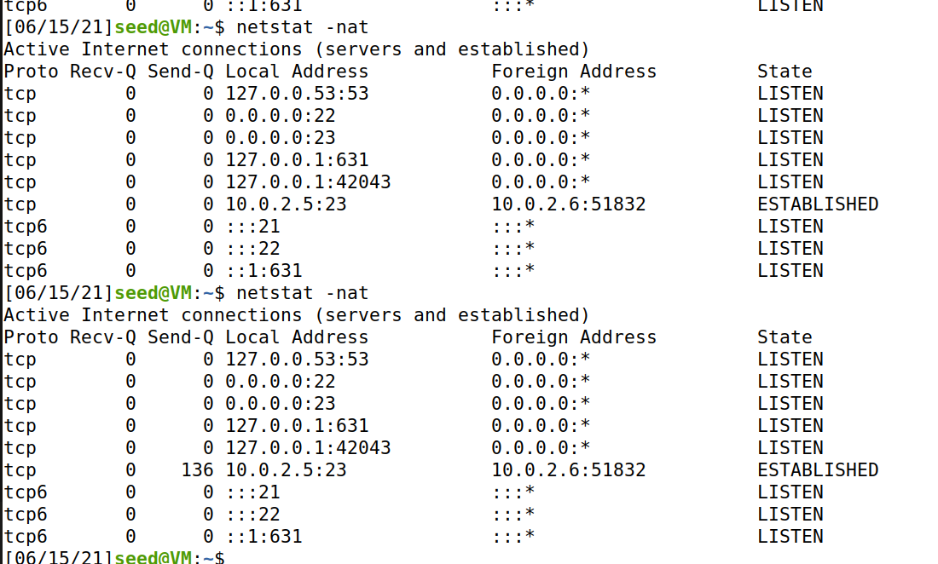

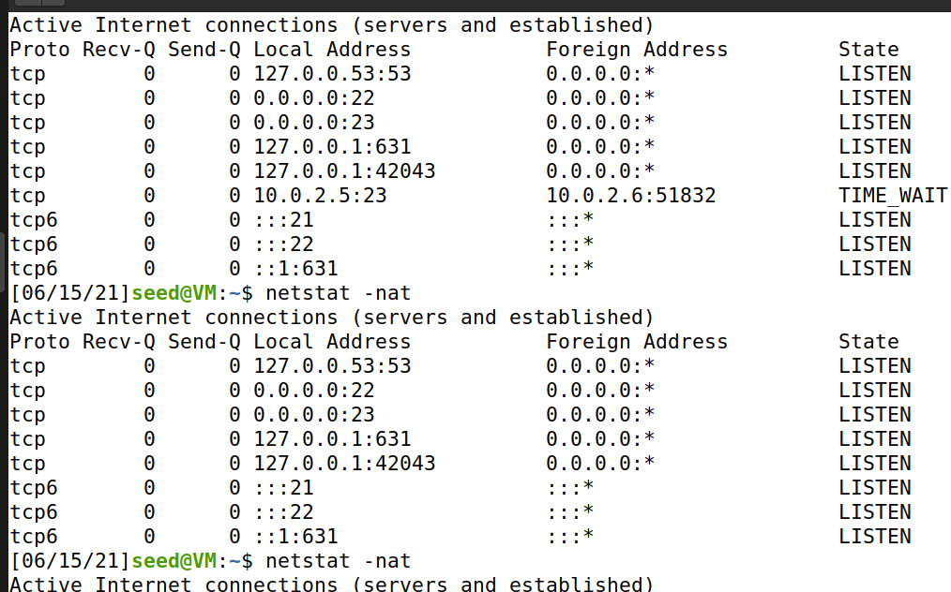

* Ending the Telnet connection and the SynFlood program changes the TCP connection with the foreign address to TIME_WAIT
* Initiating the SynFlood program but not the Telnet connection changes the state from TIME_WAIT to Listen
* Using Telnet changes the state from LISTEN to ESTABLISHED



* Using netstat -net on the Telnet connection shows only one address

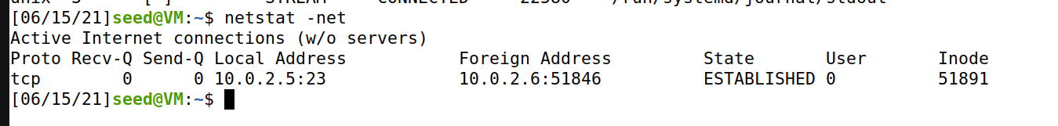

Enabling SYN Cookies